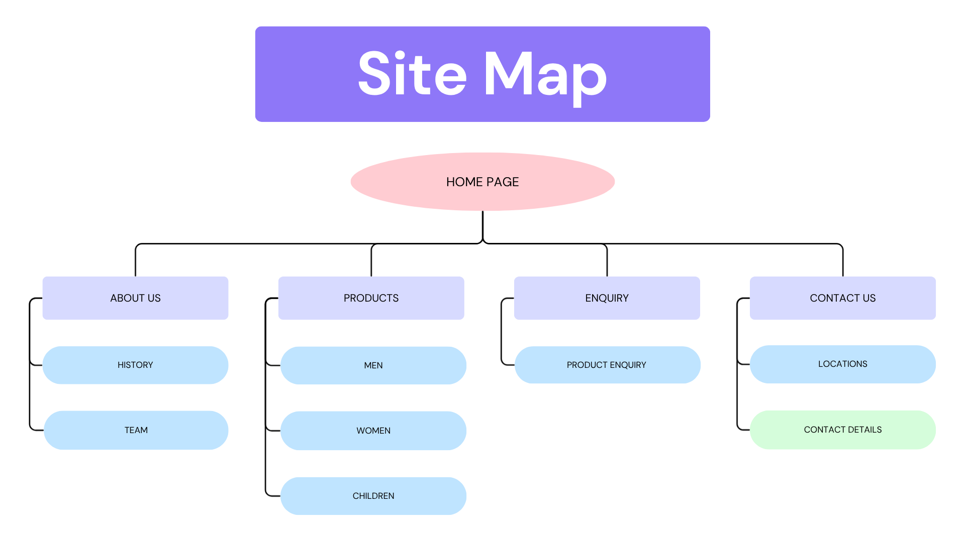
Website structure and Planning Site Map

Site map text version
1. Home (index.html)
│
├── 2. About (about.html)
│ ├── History & Mission
│ └── Team Members
│
├── 3. Products (products.html)
│ ├── Men's Collection
│ ├── Women's Collection
│ └── Children's Collection
│
├── 4. Enquiry (enquiry.html)
│
└── 5. Contact (contact.html)

Page 1: Homepage
+--------------------------------------------------+
| |
|[LOGO] [MEN] [WOMEN] [KIDS] [ABOUT] [CONTACT]
| |
+--------------------------------------------------+
| |
| [ HERO IMAGE ] |
| (Family / seasonal campaign) |
| |
+--------------------------------------------------+
| |
| "New Arrivals for the whole family." |
| |
| [ SHOP NOW → ] |
| |
+--------------------------------------------------+
| |
| [Men] [Women] [Kids] |
| (placeholder)(placeholder)(placeholder) |
| |
+--------------------------------------------------+
| Footer |
+--------------------------------------------------+

Page 2: About Us (about.html)
+--------------------------------------------------+
| [LOGO] [MEN] [WOMEN] [ABOUT] [CONTACT] |
+--------------------------------------------------+
| OUR STORY |
| |
| "Zara-inspired brand founded in 2025 |
with a passion for minimalist fashion... |
| |
+--------------------------------------------------+
| |
| OUR MISSION | OUR VISION |
| (2 text boxes side by side) |
| |
+--------------------------------------------------+
| |
| MEET THE TEAM |
| |
| [Photo] [Photo] [Photo] |
| Name Name Name |
| Role Role Role |
| |
+--------------------------------------------------+
| Footer |
+--------------------------------------------------+
Page 3: Products (products.html)
+--------------------------------------------------+
|[LOGO][MEN] [WOMEN] [KIDS] [ABOUT] [CONTACT]
+--------------------------------------------------+
| |
| MEN ▼ | WOMEN ▼ | KIDS ▼ |
| |
+--------------------------------------------------+
| |
| [Product] [Product] [Product] |
| Image Image Image |
| |
| [Product] [Product] [Product] |
| Image Image Image |
| |
+--------------------------------------------------+
| CHILDREN'S COLLECTION |
| |
| [Product] [Product] [Product] |
| Image Image Image |
| "Kid's Coat" "Kid's Shirt" "Kid's Pants" |
| |
| [Product] [Product] [Product] |
| Image Image Image |
| "Kid's Set" "Kid's Dress" "Kid's Shoes" |
+--------------------------------------------------+
| Footer |
+--------------------------------------------------+
Page 4 Enquiry (enquiry.html)
+--------------------------------------------------+
| [LOGO] [MEN] [WOMEN] [ABOUT] [CONTACT] |
+--------------------------------------------------+
| |
| PRODUCT ENQUIRY |
| |
| Full Name: [___________________] |
| |
| Email: [___________________] |
| |
| Product: [Dropdown: Coat / Shirt / etc.] |
| |
| Message: [___________________] |
| [___________________] |
| |
| [ SUBMIT ENQUIRY ] ← Button |
| |
+--------------------------------------------------+
| Footer |
+--------------------------------------------------+

+--------------------------------------------------+
| [LOGO] [MEN] [WOMEN] [ABOUT] [CONTACT] |
+--------------------------------------------------+
| |
| CONTACT US |
| |
+--------------------------------------------------+
| |
| STORE LOCATIONS: |
| |
| 📍 New York 📍 London |
| 123 Fashion Ave 45 Oxford St |
| Mon-Sat 10-8 Mon-Sat 10-8 |
| |
| [MAP PLACEHOLDER 1] |
| [MAP PLACEHOLDER 2] |
| |
+--------------------------------------------------+
| |
| CONTACT FORM: |
| |
| Name: [_________] Email: [_________] |
| Message: [___________________] |
| [ SEND MESSAGE ] |
| |
+--------------------------------------------------+
| Footer |
+--------------------------------------------------+

